Lab Environment
In this lab environment, you will be provided with GUI access to a Kali machine. The target machine will be accessible at "victim-1".
Objective: Run the following auxiliary modules against the target (victim-1):
- auxiliary/scanner/http/apache_userdir_enum — enumerates user home directories exposed by Apache (checks /~username paths).
- auxiliary/scanner/http/brute_dirs — brute-forces directory names on a web server using a wordlist.
- auxiliary/scanner/http/dir_scanner — scans for common directories and files on a web server (wordlist-based discovery).
- auxiliary/scanner/http/dir_listing — checks whether directories on the server have directory listing enabled.
- auxiliary/scanner/http/http_put — tests whether HTTP PUT is allowed and attempts to upload files.
- auxiliary/scanner/http/files_dir — searches for common files inside web directories (looks for likely filenames/extensions).
- auxiliary/scanner/http/http_login — tries to authenticate to web services using supplied credentials or brute force (forms/basic/digest).
- auxiliary/scanner/http/http_header — fetches and analyzes HTTP response headers from the target.
- auxiliary/scanner/http/http_version — probes the web server to identify its HTTP version and server banner.
- auxiliary/scanner/http/robots_txt — retrieves /robots.txt to discover disallowed or interesting paths listed for crawlers.

Solution:
Step 1: Open the lab link to access the Kali machine.

Step 2: Check if the target machine is reachable:
Command:
ping -c 5 victim-1
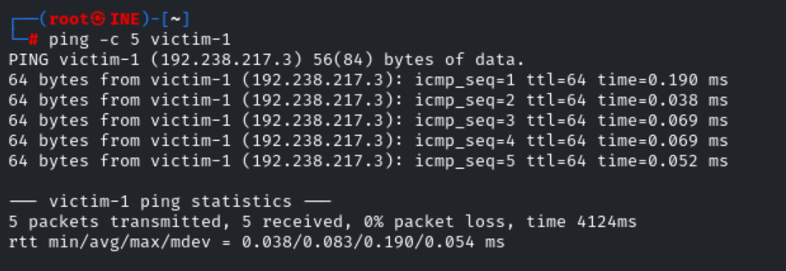
The target is reachable.
Step 3: Open the Metasploit framework console.
Command:
msfconsole -q
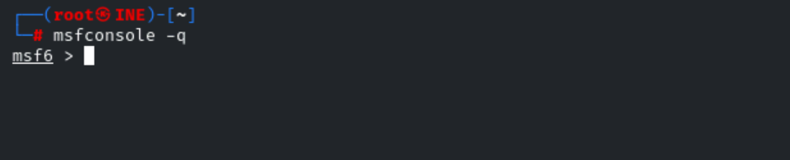
Step 4: Run the Metasploit auxiliary modules against the target one-by-one.
Module 1: auxiliary/scanner/http/http_version
Commands:
use auxiliary/scanner/http/http_version
set RHOSTS victim-1
run
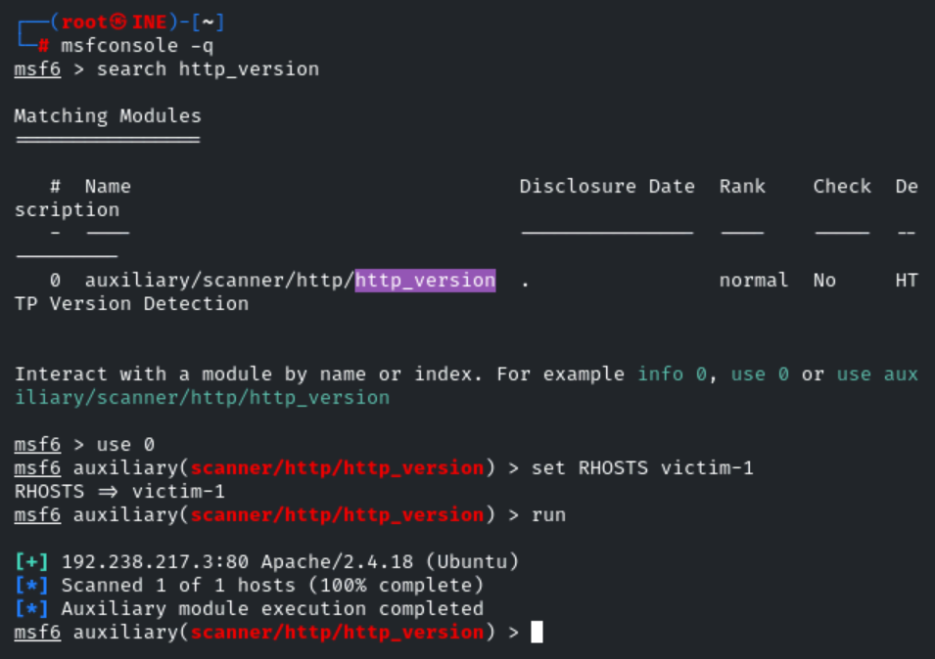
Module 2: auxiliary/scanner/http/robots_txt
Commands:
use auxiliary/scanner/http/robots_txt
set RHOSTS victim-1
run
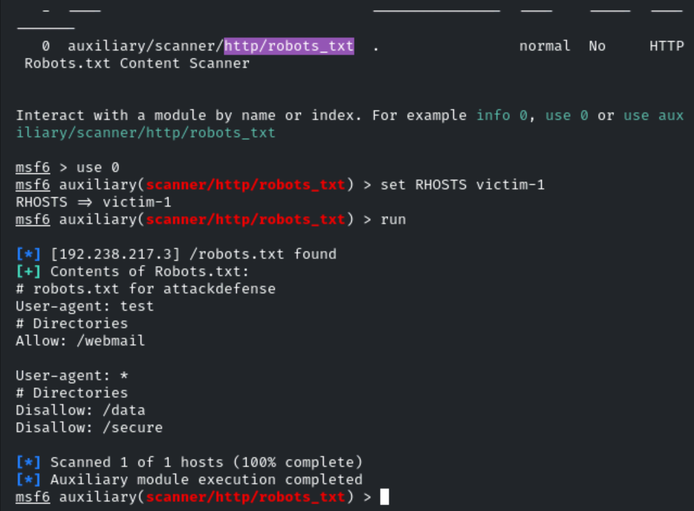
Module 3: auxiliary/scanner/http/http_header
Commands:
use auxiliary/scanner/http/http_header
set RHOSTS victim-1
run
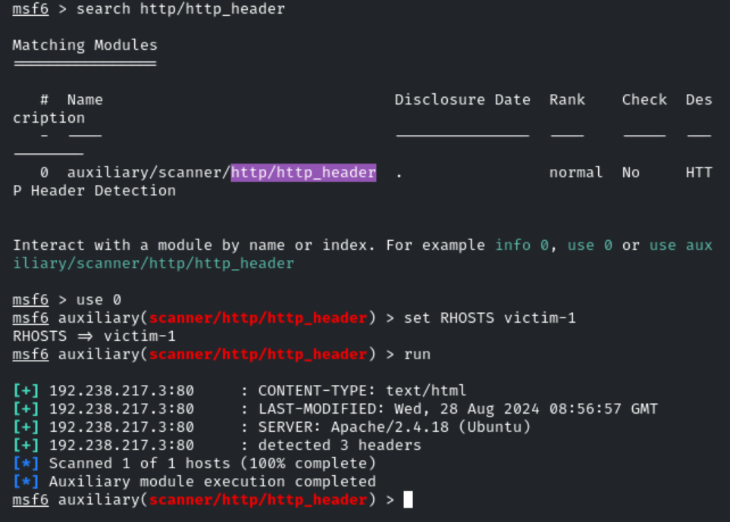
Commands:
use auxiliary/scanner/http/http_header
set RHOSTS victim-1
set TARGETURI /secure
run
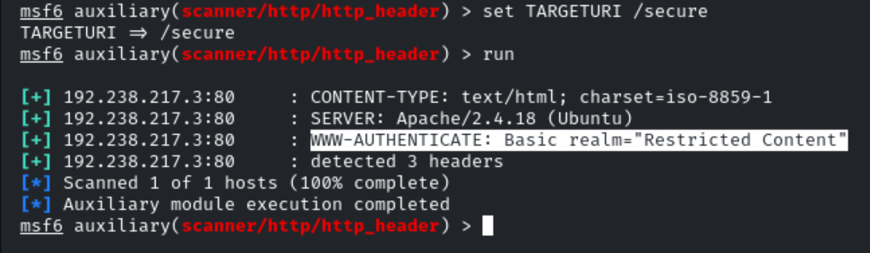
Module 4: auxiliary/scanner/http/brute_dirs
Commands:
use auxiliary/scanner/http/brute_dirs
set RHOSTS victim-1
run
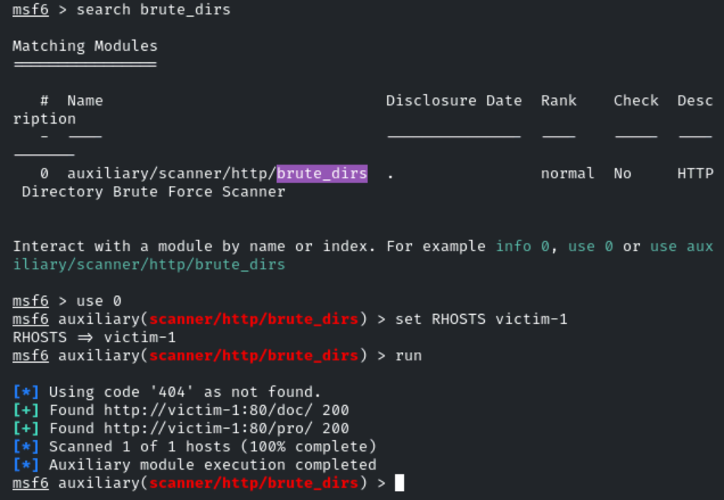
Module 5: auxiliary/scanner/http/dir_scanner
Commands:
use auxiliary/scanner/http/dir_scanner
set RHOSTS victim-1
set DICTIONARY /usr/share/metasploit-framework/data/wordlists/directory.txt
run
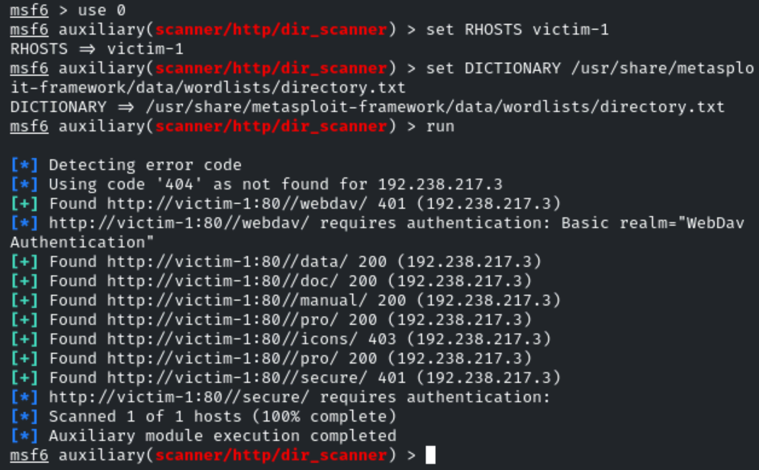
Module 6: auxiliary/scanner/http/dir_listing
Commands:
use auxiliary/scanner/http/dir_listing
set RHOSTS victim-1
set PATH /data
run
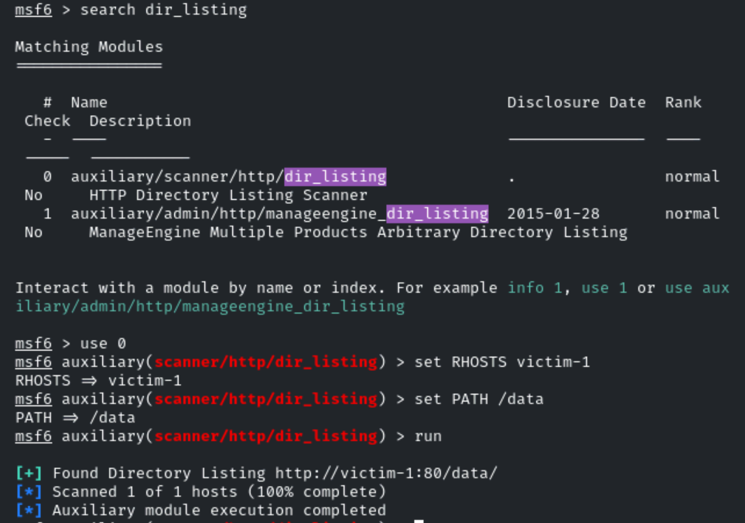
Module 7: auxiliary/scanner/http/files_dir
Command:
use auxiliary/scanner/http/files_dir
set RHOSTS victim-1
set VERBOSE false
run
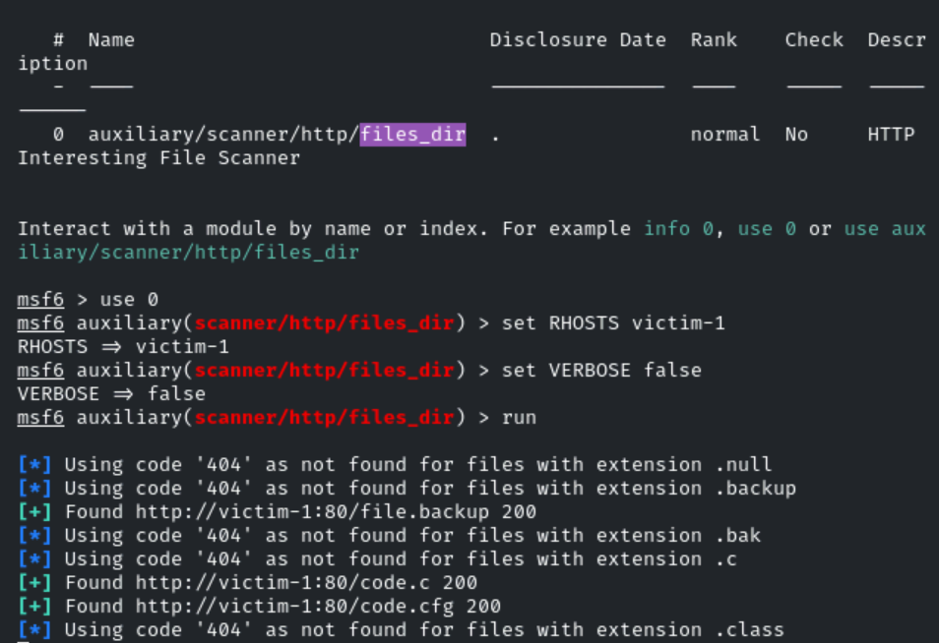
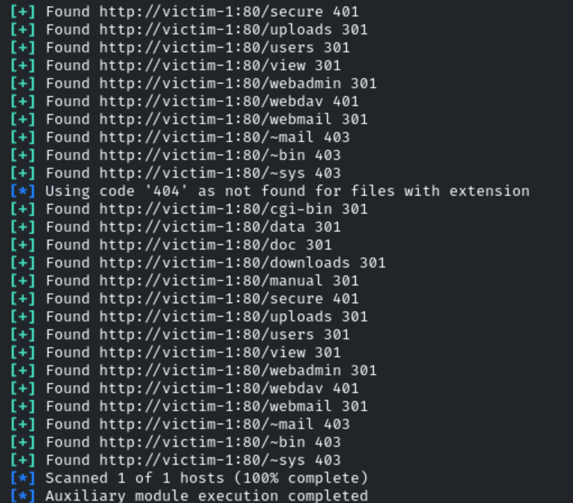
Module 8: auxiliary/scanner/http/http_put
Commands:
use auxiliary/scanner/http/http_put
set RHOSTS victim-1
set PATH /data
set FILENAME test.txt
set FILEDATA "Welcome"
run
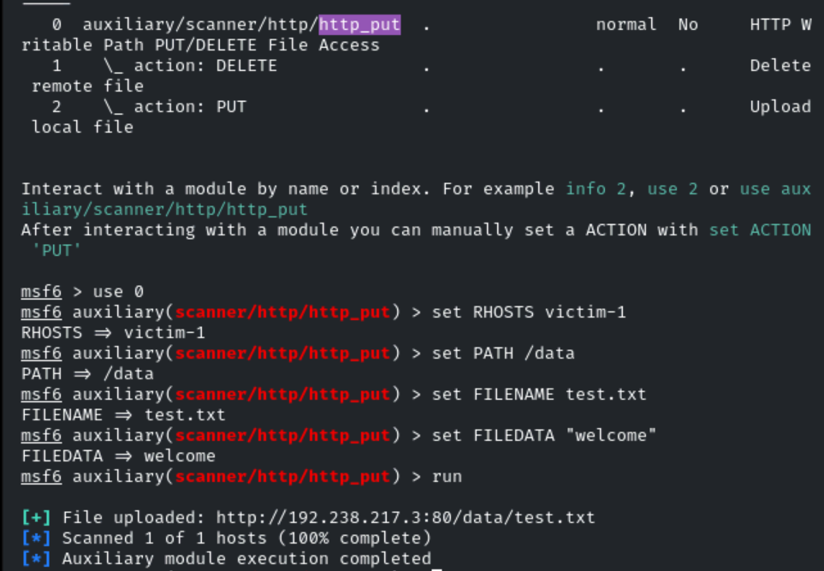
We can observe that we have successfully written a file on the target server. If the file is already exists it will overwrite it. Let’s use wget and download the test.txt file and verify it.
Commands:
wget http://victim-1:80/data/test.txt
cat test.txt

# wget is a command-line tool used to download files from the web.
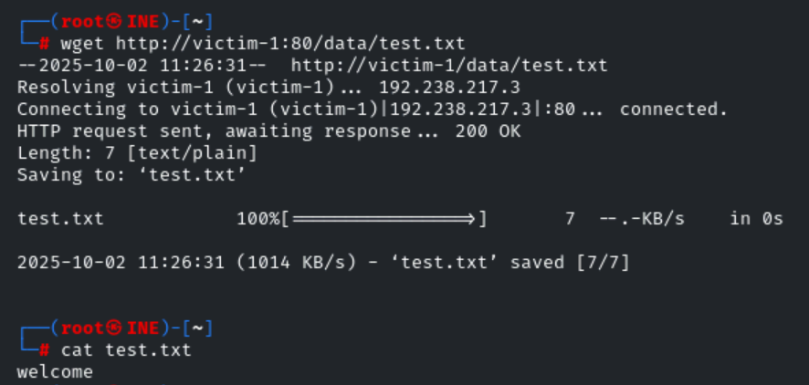
We can download the text.txt file and we can see it’s content i.e "Welcome To AttackDefense"
Now, let’s use DELETE method and delete the text.file
Commands:
use auxiliary/scanner/http/http_put
set RHOSTS victim-1
set PATH /data
set FILENAME test.txt
set ACTION DELETE
run
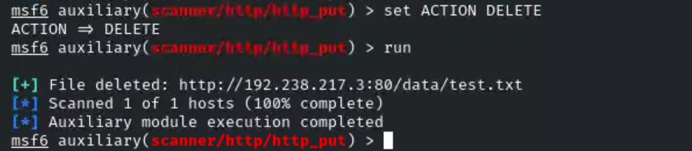
Let’s try to download the same file from the same path. This time we should receive 404 error. i.e file not found. Because we have deleted it.
Command:
wget http://victim-1:80/data/test.txt
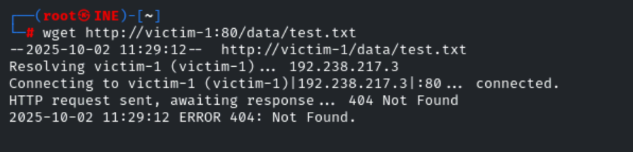
Module 9: auxiliary/scanner/http/http_login
Commands:
use auxiliary/scanner/http/http_login
set RHOSTS victim-1
set AUTH_URI /secure/
set VERBOSE false
run
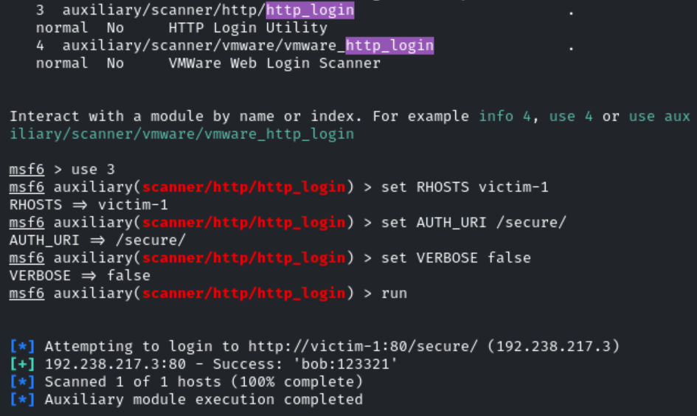
Module 10: auxiliary/scanner/http/apache_userdir_enum
Commands:
use auxiliary/scanner/http/apache_userdir_enum
set USER_FILE /usr/share/metasploit-framework/data/wordlists/common_users.txt
set RHOSTS victim-1
set VERBOSE false
run
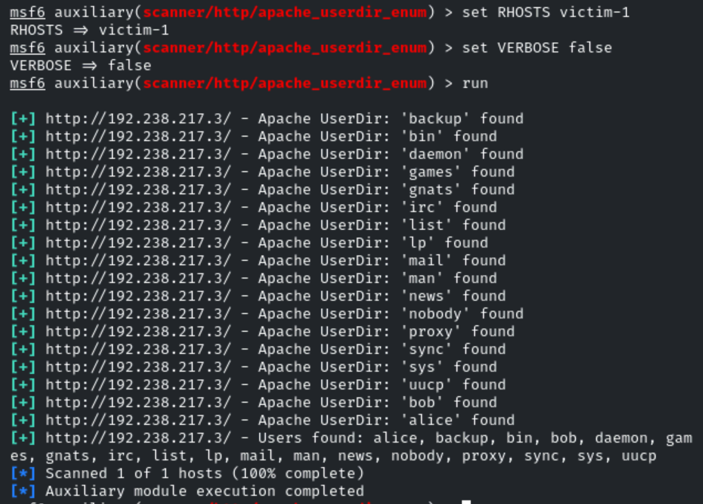
Conclusion
In this lab, we learned about Apache enumeration using the Metasploit framework modules.

